**How To Write Alt Text**

The University of Illinois Press is committed to making online journals content accessible to as many readers as possible. Alternative text for images, charts, and maps plays aloud for readers with screen readers or text-to-speech software. It can also be viewed by readers whose limited access to digital bandwidth prevents visual content in journal articles from displaying.

As the author, you are the authority on the images in your article, so just as we ask you to provide captions for all images in your article, we also ask you to also provide alt text. Our copy editors will edit your alt text just as they edit text and captions, but here, for your benefit, are some best practices we have found useful.

MANUSCRIPT PREPARATION: Alt text should be included with the image captions for your manuscript as numbered items at the end of your article, e.g.:

Figure 1. caption text

Figure 1 alt text: description of image.

**THE TEXT ITSELF:** Avoid long descriptions that will disrupt the reader’s concentration on the main text. Keep it to 25 words if possible, 50 words maximum. Describe what you see as concretely and objectively as possible, moving from general description to interpretation, **with a focus on what the image means beyond just its visual characteristics**. What is important to point out in the alt text will vary depending on the context of the image. Below is an example:



### **Alt-text with no context:**

A mostly empty stadium.

### **Alt-text on a page about recent turnout for track tryouts:**

Harvard Stadium with two lone runners bounding up the steps.

### **Alt-text on page about renovation projects:**

Harvard Stadium with cracked concrete pillars.

**STYLE:** Use proper punctuation and check your spelling, as errors can confuse screen reading software. Use the present tense. Do not use all lowercase letters, emojis, or other nonstandard vocabulary. Avoid constructions such as “a photo of” or “an image of.”

REPEAT TEXT VERBATIM: If an image contains text, repeat that text verbatim in the alt text.

AVOID REDUNDANCY: If information about the image is available in the main text or the image captions, do not repeat it in the alt text.

SKIP ORNAMENTS: If an image is purely decorative, such as a design motif, skip the alt text so you don’t distract the reader. However, if a visual device such as a corporate logo seems relevant, provide a brief description.

SUMMARIZE TABLES AND GRAPHS: For complex tables and graphs, alt text should be used in tandem with the caption to convey the main thrust of the data presented.

AVOID AUTOMATIC ALT TEXT: Some software programs provide automatic alt text, but it is often inadequate. We ask that our authors write the content themselves.

**EXAMPLES OF HELPFUL AND UNHELPFUL ALT TEXT**



**Unhelpful alternative text:** Student

**Bad alternative text:** Female student with long black hair standing in the Case Western Reserve University on-campus student bookstore reading a calculus textbook with a copper spring on the cover.

**Good alternative text:**Female student reading a calculus textbook in the Case Western Reserve University bookstore.

The first example excessively describes the image and detracts from the key information, whereas the second example doesn't describe much about the image.

The good example succinctly provides the information necessary to understand the image. If you use the bad alternative text example, the listener might become confused or miss the primary purpose of the image.

**WRITING ALT TEXT FOR CHARTS, GRAPHS, AND MAPS**

Some people understand complex information best when it's presented visually, such as a chart or diagram, while others find that reading the information suits them better. For people who use screen readers, a good text equivalent of the information that’s presented graphically is essential for their understanding.

For simple graphics, providing a succinct, informative text alternative is usually fine. But for complex graphics, it's not enough to provide a screen reader user with only short alternative text, such as "population graph." You also need to think about the information that the graphic conveys, such as the categories of data being shown, trends, and maximum and minimum values.

Below are several examples.

**GRAPHS**

Usually, the absolute best alt text for any chart or graph is something like: “Chart showing an upward trend over time; refer to the data table on this page for details.” If possible, include the source data table for any chart or graph within the source document. If that isn’t possible, depending on the complexity of the chart, either general trends should be described, or each data point should be described in the alt text. Consider the intended context of the graph when determining how much detail to include.

The following graph can be described relatively simply: “Line graph showing an upward trend in cell phone services from 2001 through 2010, with a corresponding downward trend in residential phone services over the same period.”

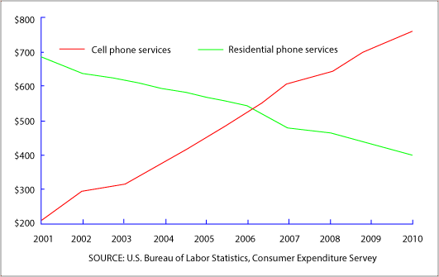

For the bar graph below, however; it is necessary to provide the various data points in order to convey the information. So you would write something like: “Graph of favorite cereals by vote. Life 6 votes, Cornflakes 4 votes, Kix 3 votes, Cheerios 2 votes.”

Notice that these figures have been arranged in descending order, not the order in which they appear. This allows for an easier understanding of the trends. It would be of more importance if there were a list of more items on which to vote, but this method of arranging in descending (or ascending) order should be used unless the graph has other sequential structure to consider (such as dates). This method is easier for assistive technology users to understand the data being presented. That way if the user needs to quickly find the highest or lowest value, it is much easier than re-reading every item again. Note also that “votes” has been spelled out each time. This avoids confusion about what the various numbers are referencing.

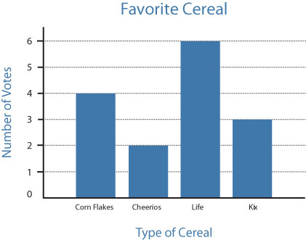

**ORGANIZATIONAL CHARTS**

Organizational charts can be tricky to describe using alt text. The more complex the org chart, the more words are required to accurately present the information. It can become very cumbersome to navigate alt text describing an organizational chart if there are a large number of elements.

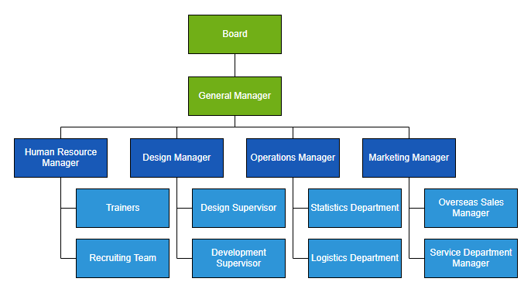

This organizational chart would be complex to describe as alt text. It is better rendered as a nested list, like so:

* Board
* General Manager
* Human Resource Manager
* Trainers
* Recruiting Team
* Design Manager
* Design Supervisor
* Development Supervisor
* Operations Manager
* Statistics Department
* Logistics Department
* Marketing Manager
* Overseas Sales Manager
* Service Department Manager

**FLOW CHARTS**

Flow charts can consist of many elements, sometimes requiring a lengthy description as alt text. The more interconnected the elements of the flow chart, the lengthier the description.

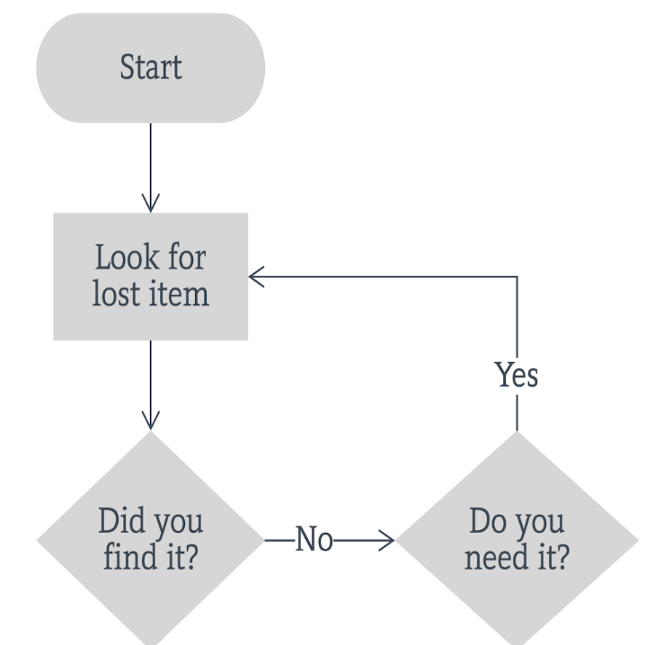

**An example of alt text for the above**: “Steps to finding an object: To start, look for lost item. Did you find it? No. Do you need it? Yes. Look for lost item.” A conscientious reader does not need to be told that the cycle should continue until either the item is found or is no longer needed.

**MAPS**

Maps can be extremely difficult to describe accurately using alt text. Often the alt text used is simply “map of…” This is not especially useful for an assistive technology user who might actually want to know how to get from point A to Point B or the location of a specific destination. However, if the information conveyed by the map (directions or specifically cited locations like mailboxes or coffee shops) is thoroughly covered in the text of the document, the alt text “map of mailbox locations” might be perfectly appropriate.

Remember the context of the map needs to be considered. It’s not always necessary to describe the entire map. The map below could take hundreds of words to describe in the alt text.

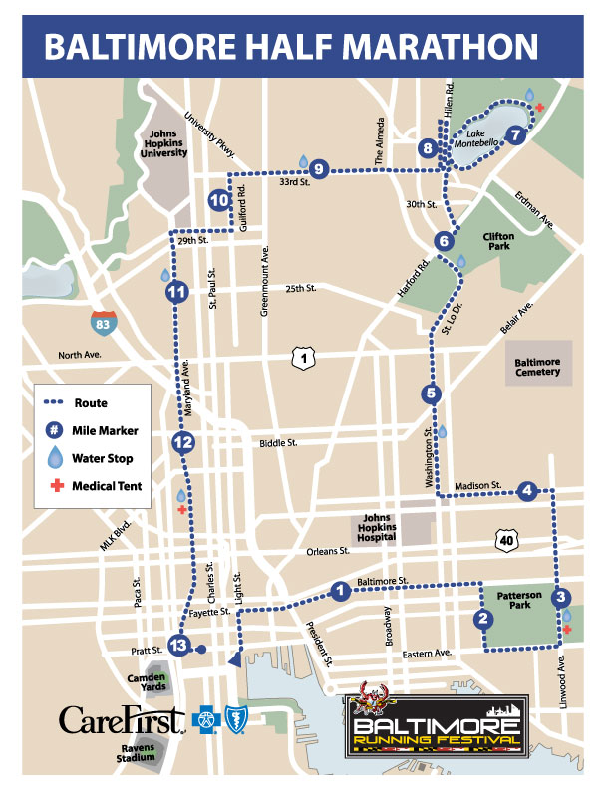

However, the best way to provide the intended information for this particular map is to give clear directions to each point listed on the map. So, you might write:

“Map of the course for the 2021 Baltimore Half Marathon. Start at the intersection of Pratt and Light streets. Make the second right onto Baltimore Street. Turn right at the fifth intersection at Patterson Park. Then take the next left onto Eastern Avenue and proceed one block. Turn left onto Linwood Avenue.…” and so on, describing the path of the marathon. This is the information intended by the map. Again, if the text around this map already includes step-by-step directions, it is not necessary to reiterate them in the alt text. “Map of Route for 2021 Baltimore half marathon” would suffice.